Data Structures and Practice #7
Department: Cyber Security Student ID: 201920669 Name: KimWooSung
Topic | Binary Tree Traversal
Learning objectives | The students can understand the binary tree traversal algorithms
Basic data structure | typedef struct TreeNode *TreePointer;  typedef struct TreeNode {  int data;  TreePointer leftChild; TreePointer rightChild;  } TreeNode;  void inorder(TreePointer ptr)  {  if (ptr) {  inorder(ptr->leftChild); printf("%d ", ptr->data); inorder(ptr->rightChild);  }  return;  }  void preorder(TreePointer ptr)  {  if (ptr) {  printf("%d ", ptr->data); preorder(ptr->leftChild); preorder(ptr->rightChild);  }  return;  }  void postorder(TreePointer ptr)  {  if (ptr) {  postorder(ptr->leftChild); postorder(ptr->rightChild); printf("%d ", ptr->data);  }  return;  }
Problem 1  [20 points] | 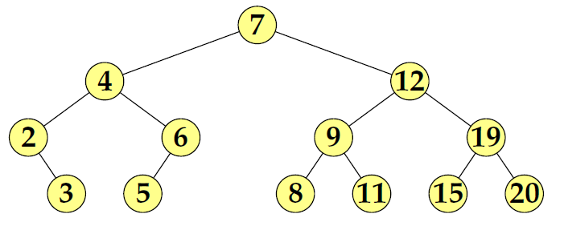  1) Show the results of Inorder traversal.  2 3 4 5 6 7 8 9 11 12 15 19 20  2) Show the results of Preorder traversal.  7 4 2 3 6 5 12 9 8 11 19 15 20  3) Show the results of Postorder traversal.  3 2 5 6 4 8 11 9 15 20 19 12 7
Problem 2  [20 points] | Draw the shape of each tree when the results of Inorder traversal and Preorder traversal are given like the followings (Note: Show the reasoning process.)  1) inorder: 4 2 5 1 3, preorder: 1 2 4 5 3  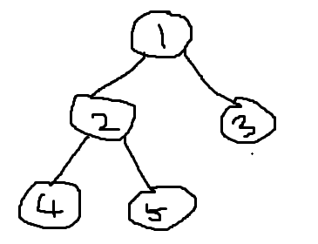  Preorder’s first node is 1. So, root is 1 node. In inorder tree, first node is the leftmost node and last node is the rightmost node. And we can know 3 is right child of 1 because, in-order 3 is right of 1. Preorder’s second node is 2 so we know level 0 (1)’s left child is 2. In addition, preorder’s third node is 4, we can know level 1(2)’s left child is 4. And last 5 is 2’s right child.  2) inorder: 4 2 5 1 8 6 9 3 7, preorder: 1 2 4 5 3 6 8 9 7  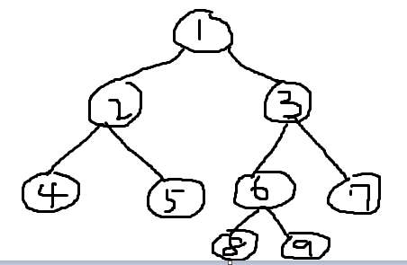  Preorder’s first node is 1. So, root is 1 node. In inorder tree, first node is the leftmost node and last node is the rightmost node. And I can guess the left side of 1 is 4, 2, 5, and 8, 6, 9, 3, 7 is right side of. In the left side, we know 2 is left child of 1 in preorder. So, we can find 4 is left child of 2, 5 is right child in inorder. In the right side, we know 3 is right child of 1 in preorder because nodes of left side finish. So we can find 8, 6, 9 is left side of 3, 7 is right child of 3. 6 is left child of 3 in preorder, and 8 is left child of 6, 9 is right child of 9. Then we can draw the shape of tree.
Problem 3  [20 points] | 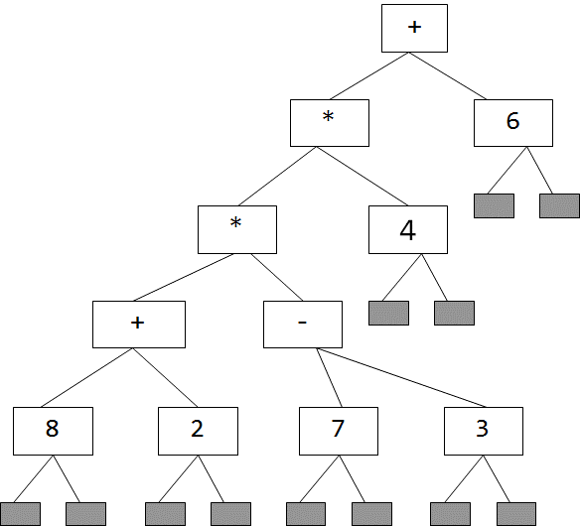 | 1) Show the Inorder traversal result.  (((8+2)*(7-3))*4)+6  2) Show the Preorder traversal result.  +(*(*(+82)(-73))4)6  3) Show the Postorder traversal result.  (((82+)(73-)*)4*)6+
Problem 4  [40 points] | 1) When a tree is given like below select the proper traversal algorithm to evaluate the expression. Show why your selection is reasonable.  2) Show how to change the basic data structure to get the evaluation results of the expression. Assume that the operators are limited to +, -, *, and /. The operands are limited to integer.  typedef struct TreeNode *TreePointer;  typedef struct TreeNode {  int data;  int operation;  int operand;  TreePointer leftChild, rightChild;  } TreeNode;  3) Show how to change the traversal code to get the expression evaluation result. (Note: Refer to the postOrderEval() in the lecture note)  Void postOrderEval(Treepointer Node){  If (node){  postOrderEval(Node->leftChild);  postOrderEval(Node->rightChild);  if(Node->operation == ‘+’ || Node-> operation == ‘-‘ || Node-> operation == ‘/’ || Node -> operation == ’*’){  if(Node-> operation==‘+’){  Node->operand = Node ->leftChild->operand + Node ->rightChild->operand;  }  if(Node-> operation==‘-’){  Node->operand = Node ->leftChild->operand - Node ->rightChild->operand;  }  if(Node-> operation==‘*’){  Node->operand = Node ->leftChild->operand * Node ->rightChild->operand;  }  if(Node-> operation==‘/’){  Node->operand = Node ->leftChild->operand / Node ->rightChild->operand;  }  }  Else if(Node -> operand ==NULL){  Return 0;  }  }  }

